**Task 10**

1. **Installed java:**

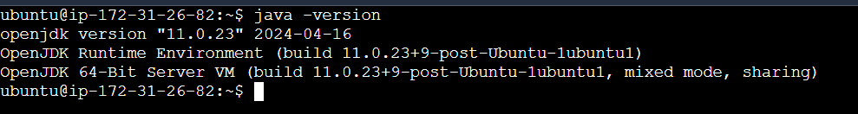

1. **Installed Jenkins:**

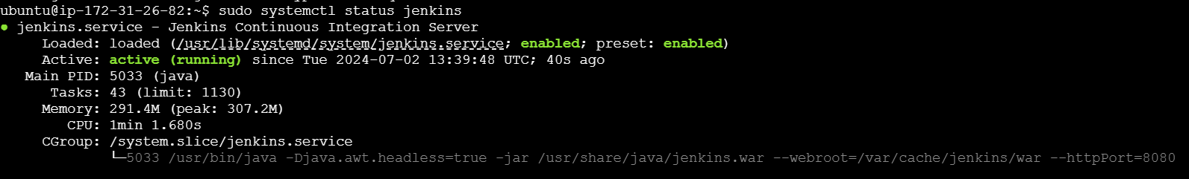

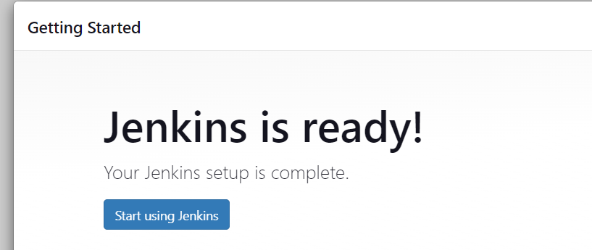

1. **Install docker on ec2**:

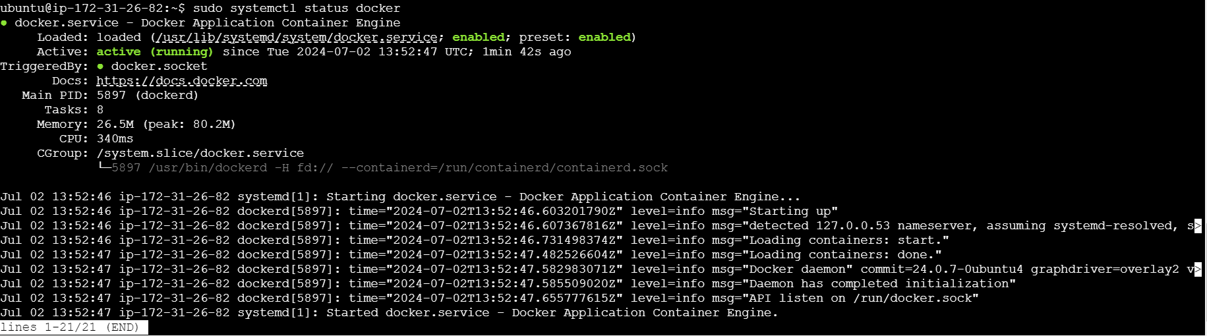

1. **Sign in to Jenkins:**

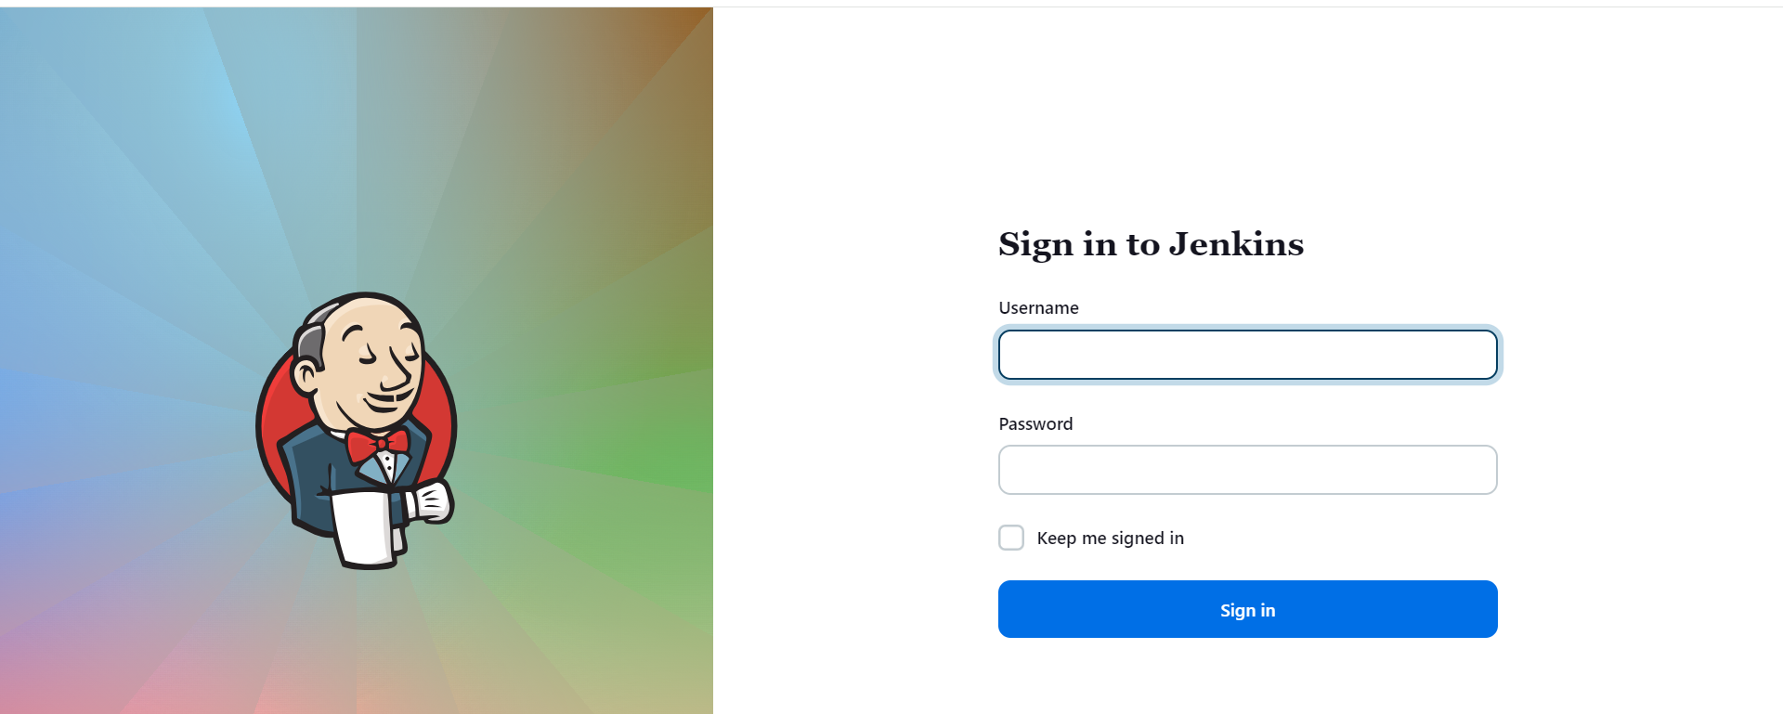

1. **Creating projects:**

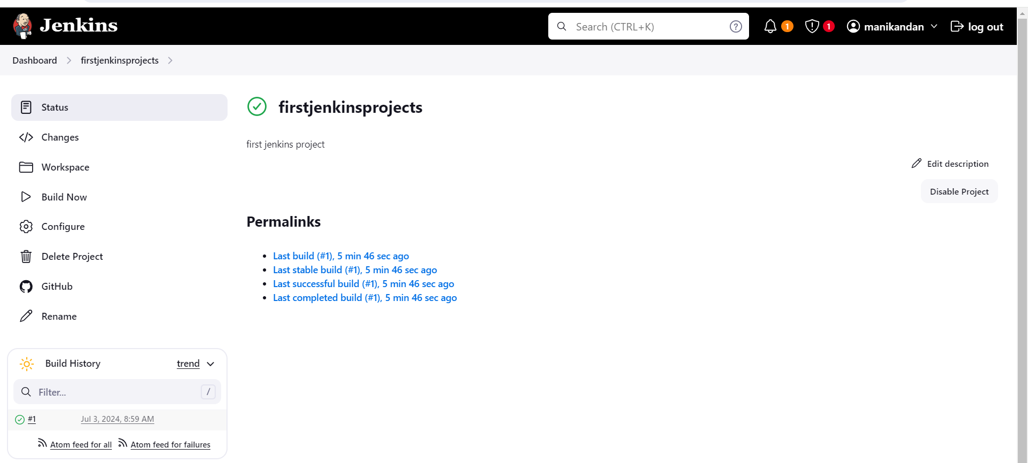

**5(a). Console output:**

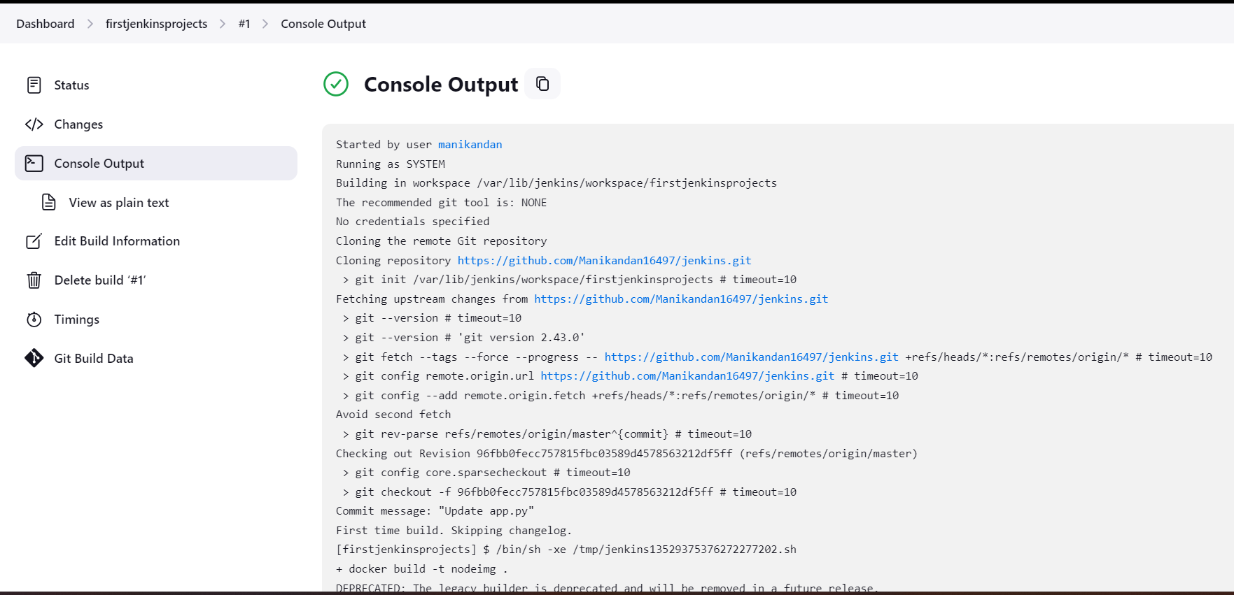

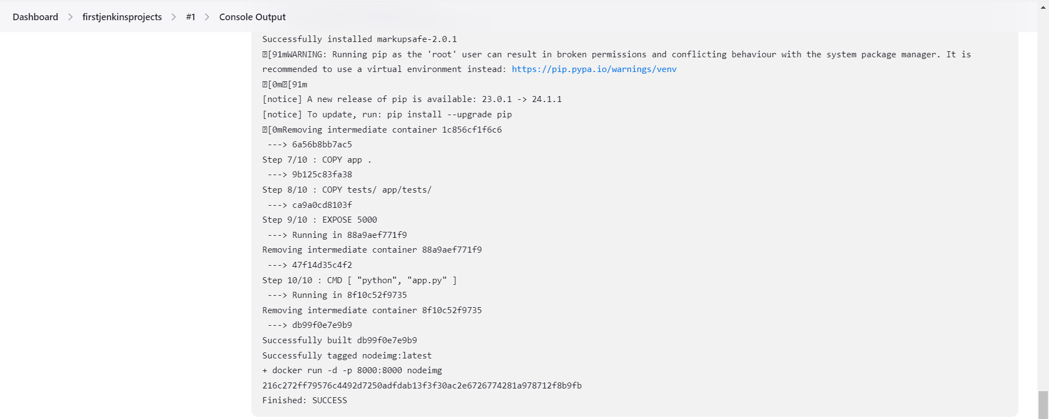

1. **Create users (dev and test job):**

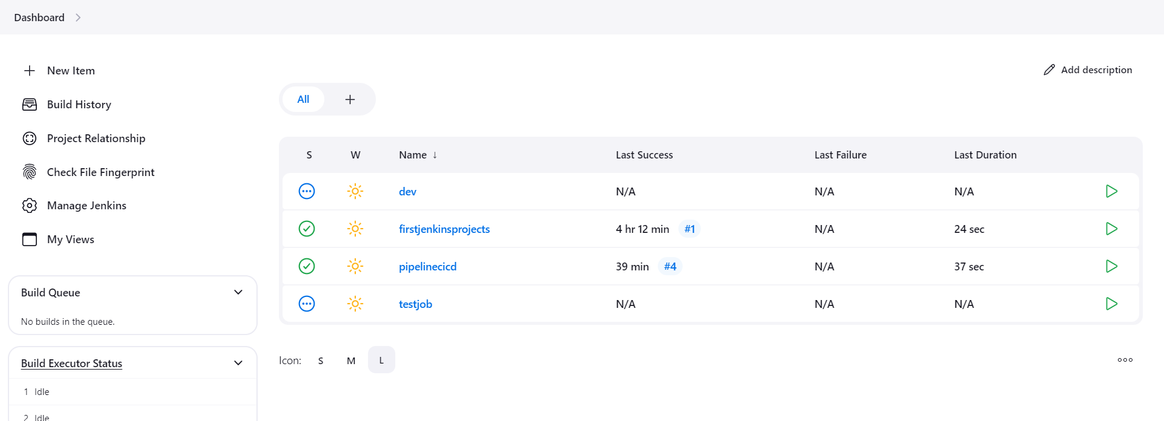

1. **Manage roles:**
2. **Global roles:**

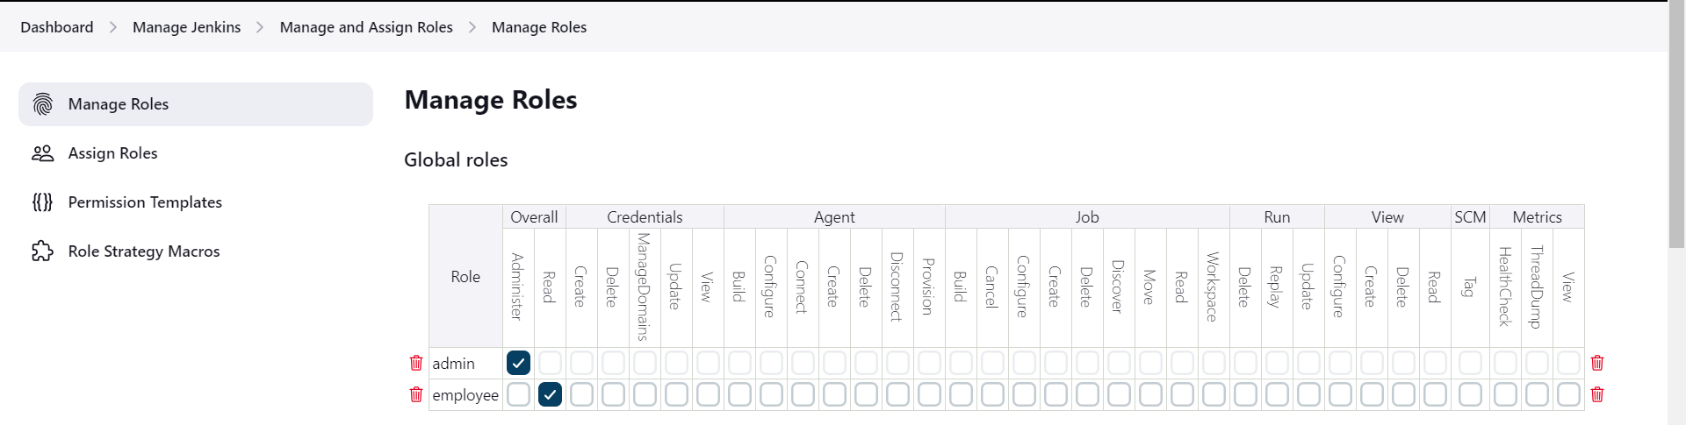

1. **Item role:**

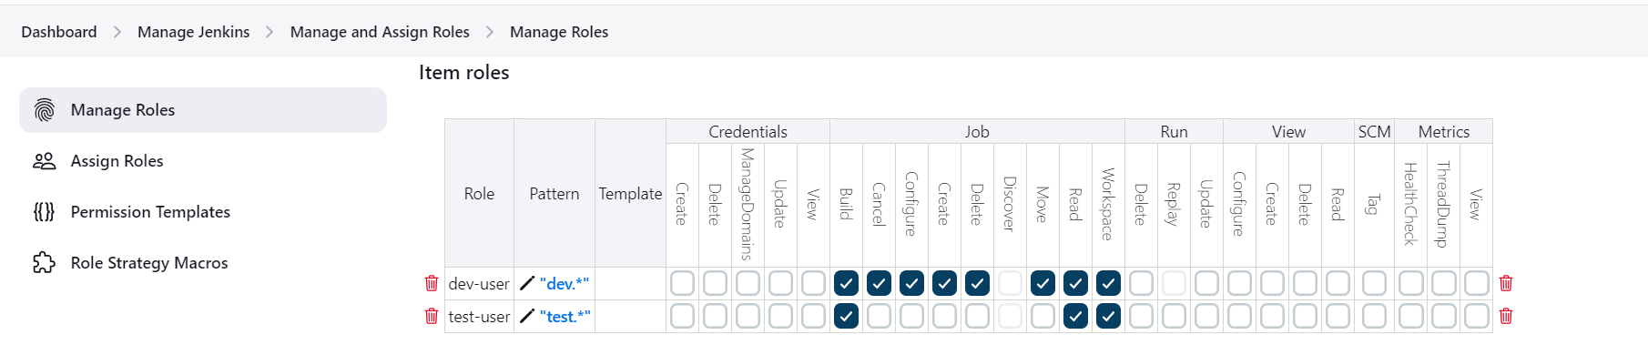

1. **Assign roles (global and item roles):**

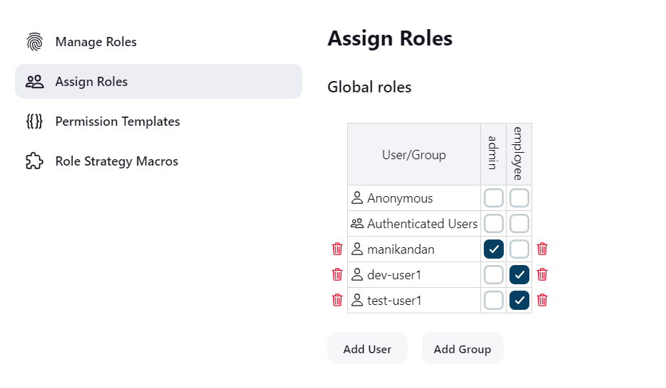

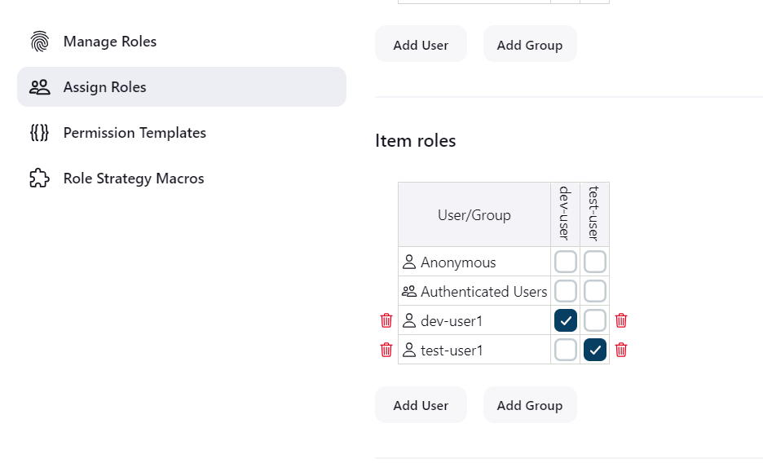

1. **Sign in to dev user:**

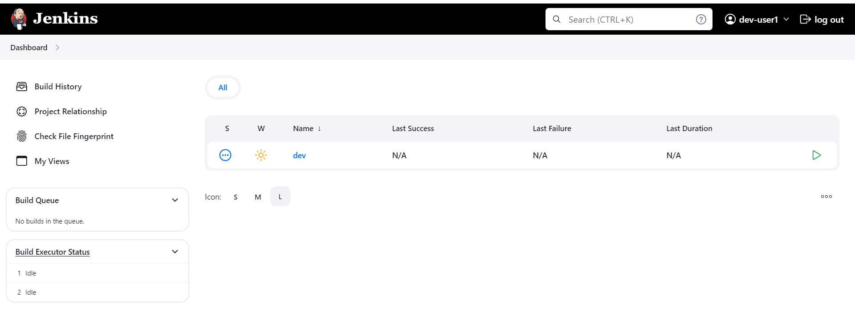

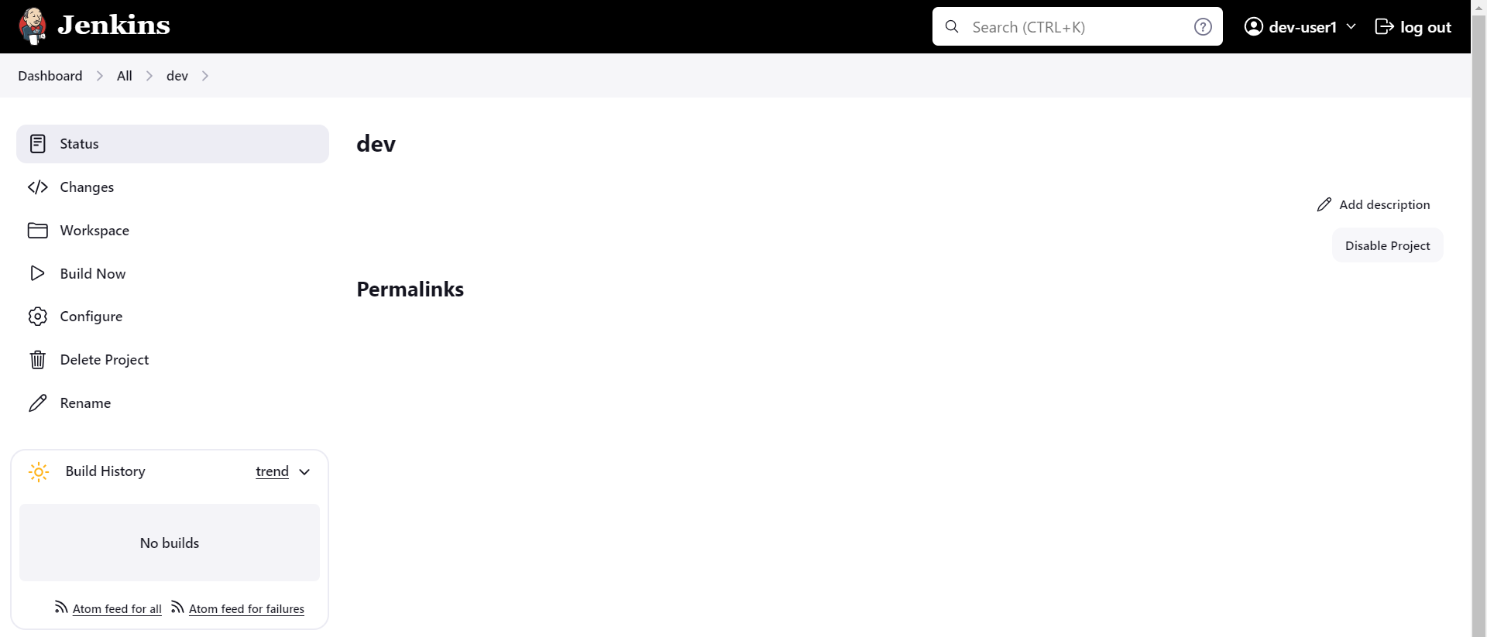

1. **Sign in to test user:**

